
Al-Zaytoonah University of Jordan


Faculty of Science and Information Technology

Department of Computer Science

Prepare by:

Adham ameen abuhager )202410471(
- Raid Medhat Shream (202120525)

Supervisor

Dr.Mohammad Abdallah
First Semester 2025/2026

ABSTRACT

This project focuses on automating event booking and private event management within a university environment through the development of a web-based Event Management System. The system replaces manual, paper-based registration and reservation processes with a digital platform designed to improve operational efficiency, accuracy, and reliability for both users and administrators.

The system allows students and users to browse events, access detailed information, reserve seats, and manage their reservations through a structured and secure interface. Administrators and event organizers are provided with tools to create and manage events, monitor reservations, and enforce capacity constraints using role-based access control. This design supports organized event administration and reduces manual intervention.

An Automatic Waiting List Algorithm is implemented to manage events that reach full capacity. When no seats are available, additional users are placed in a waiting list. Upon cancellation, the system automatically assigns the available seat to the next eligible user, ensuring consistent allocation of capacity and maintaining data integrity. Concurrent reservation handling is also addressed to prevent overbooking.

Security is an integral part of the system architecture. User authentication is implemented using BCrypt password hashing to protect sensitive credentials, alongside database-level security measures. The system follows established software engineering practices to ensure data integrity, confidentiality, and system reliability.

The application is developed using ASP.NET Core MVC, adhering to the MVC architectural pattern, with SQL Server as the database management system. This architecture supports maintainability, scalability, and structured development. The system is evaluated based on functional correctness, performance, security, and user acceptance, demonstrating the application of software engineering principles in a real-world web-based information system.
Table of Contents
1. Introduction 5
1.1 Project Description 5
1.2 Market Demographics 6
1.3 Tasks 6
1.4 The Scope of the Work 7
1.5 Stakeholders 7
1.5.1 <Stakeholder Name> 7
1.6 Stakeholder and User Descriptions 7
1.7 Stakeholder Summary 8
1.8 User Summary 8
1.9 User Environment 8
1.10 Stakeholder Profiles 9
1.11 Product Scenarios 9
2. Requirements Specification 10
2.1 Product Use Cases 10
2.2 Functional Requirements 10
2.2.1 User Authentication 10
2.3 Data Requirements 10
2.3.1 Submit Project Proposal 10
3. Design 12
12
3.1 Proposed Software Architecture 12
3.2 User Interface 14
3.3 Object Design 14
4. Test Plans 15
4.1 Approach 15
4.2 Test Cases 15
References 16
Appendix User Interface 17
Appendix Snipping Code 18

Table of Figure

Figure 1 Use Case Diagram 8
Figure 2 Schema 10
Figure 3 component diagram for the Submit Project Proposal 11
Figure 4 class diagram. 12
Figure 5 Sequence Diagram 13

Chapter 1

Introduction

Project Description
Over the years, the university administration has faced significant challenges in documenting events and reporting activities to senior management. Students have also struggled to keep track of events due to inadequate documentation and insufficient event announcement mechanisms. Reliance on traditional event management methods has led to numerous problems, including lost records, limited access to information, and a lack of timely updates on available events.

In response to these challenges, the University Events Management System was developed as an interactive web platform designed to organize, document, plan, and create university events more efficiently. The system provides a comprehensive solution for managing various activities, such as workshops, seminars, and sporting events, and contributes to enhancing the quality of the educational experience by offering students organized and reliable opportunities to participate in extracurricular activities and gain practical experience throughout their academic journey.

The system features a user-friendly and straightforward interface that serves two main user groups. It allows administrators to create events, manage their details, track registration numbers, and control the capacity of each event. Furthermore, it provides accurate data to support reporting and administrative decision-making. Conversely, it enables students to view available events, register electronically, and track their registration status without the need for traditional manual procedures.

This system helps address the shortcomings of manual booking systems, such as long queues, lost records, and the lack of up-to-date information on remaining event capacity. Thus, the university's events management system serves as an effective tool to support the institutional organization of university activities, enhance communication between administration and students, and achieve more accurate and transparent management of university events.

Market Demographics

The system is targeted at two main groups within the university:
- University Students: The primary beneficiaries who need a digital platform to browse and register for events easily instead of manual queuing.
- System Administrators (University Staff): The authorized personnel responsible for creating events, managing capacity, and overseeing the booking process.

Tasks.
Table 1 Project Timeline
WBS | Task Description | Start Date | Finish Date | Progress
1 | Task 1 Research and Analysis | 11/04/2025 | 11/17/2025 | 75%
2 | Task 2 Requirements Analysis | 11/18/2025 | 11/30/2025 | 90%
3 | Task 3 System Design & Database | 12/01/2025 | 12/21/2025 | 95%
4 | Task 4 Implementation and Coding | 12/23/2025 | 12/23/2025 | 85%
5 | Task 5 Testing & Final Documentation | 12/24/2025 | 01/06/2025 | 100%

The Scope of the Work
In-Scope:
- User Authentication (Registration, Login, Role Management).
- Event Management (Create, Edit, Delete, View).
- Booking Mechanism with Capacity Validation.
- Automatic Waiting List Handling.
- User Profile Management (Change Password, View My Bookings).
Out-of-Scope:
- Online Payment Integration (Events are free for students).
- Mobile Application (Currently limited to Responsive Web).

Stakeholders

- Project Supervisor: Dr. [Insert Name] (Responsible for guiding the development).

- University Administration: (The entity interested in automating the event process).

- IT Department: (Responsible for hosting the system).

Stakeholder and User Descriptions
- User 1: Administrator (Admin)
  - Description: Represents the university staff member who has full control over the system.
  - Responsibilities: Creates new events, sets capacity limits, manages the waiting list logic, and views registered students.
  - Technical Role: Identified in the database by the Role="Admin".
- User 2: Student
  - Description: Represents the university student currently enrolled in the semester.
  - Responsibilities: Browses the events list, books seats, joins the waiting list if full, and cancels bookings if necessary.
  - Technical Role: Identified in the database by the Role="Student".

Stakeholder Summary

Name | Description | Responsibilities
Project Supervisor | The academic advisor overseeing the project. | Reviews the project progress, guides technical decisions, and evaluates the final outcome.
University Administration | The higher management of the university. | Interested in the system's ability to streamline operations and gather data on student activities.
IT Department | The technical support team at the university. | Responsible for hosting the web application and maintaining the database server.
Student Affairs | The department organizing events. | Provides the requirements and specifications for the booking and waiting list logic.

User Summary

Name | Description | Responsibilities | Stakeholder
Administrator (Admin) | University staff members who manage events. | Manage events and view registrations | Student Affairs / IT Dept
Student | Current university students who attend events. | Browse events and register for participation | Students

User Environment

The University Event Management System is a web-based application designed to be accessible and responsive.
- Platform: The system is accessible via standard web browsers (Google Chrome, Microsoft Edge, Firefox).
- Device Support: It features a Responsive User Interface (UI) built with Bootstrap, allowing it to function seamlessly on desktop computers, laptops, tablets, and smartphones.
- Server Side: The application runs on an IIS Server capable of hosting ASP.NET Core applications, connected to a SQL Server database.

Stakeholder Profiles

Profile 1: The Student
- Technical Skills: High. Comfortable using web applications and mobile devices daily.
- Motivation: Wants a fast, hassle-free way to book events without standing in long queues.
- Pain Points: Frustration with manual registration, lack of information about available seats, and scheduling conflicts.
Profile 2: The Administrator
- Technical Skills: Moderate to High. Familiar with office software and administrative tools.
- Motivation: Needs an efficient tool to control event capacity and manage waiting lists automatically.
- Pain Points: Difficulty in tracking manual sign-ups, handling cancellations manually, and preventing overbooking.

Product Scenarios

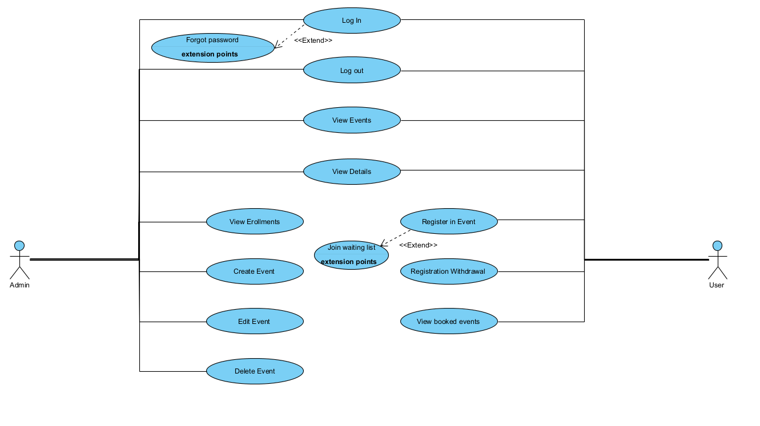

Figure 1 Use Case Diagram
This use case diagram illustrates the interactions between the two main actors, Admin and User, and the University Event Management System, and it can be clearly understood through the following real-life scenarios.
The User begins interaction with the system by logging in, with the optional Forgot Password use case extending the login process when authentication issues arise. Once authenticated, the user can view available events and access detailed information about each event. Based on this information, the user may choose to register for an event, withdraw a registration, or review previously booked events. When the session ends, the user logs out securely.

This interaction is reflected in Scenario 1: Booking a Popular Event. Ali, a Computer Science student, logs into the system and views the list of available events. After selecting the “Cybersecurity Workshop” and reviewing its details, he sees that seats are still available. He proceeds with the Register in Event use case, and the system immediately confirms his booking with an Active status. This scenario demonstrates the normal registration flow, where capacity is available and the booking is completed successfully without manual intervention.

The diagram also includes an extension to the registration process through the Join Waiting List use case, which is activated when an event reaches full capacity. This is illustrated in Scenario 2: The Automatic Waiting List. Sara logs into the system and attempts to book the same workshop, but the system indicates that the event has reached its maximum capacity. Instead of rejecting the request, the registration process is extended to add Sara to the waiting list. The system notifies her that her status is Waiting, allowing her to monitor her booking through the View Booked Events use case.
When Ali later withdraws from the event using the Registration Withdrawal use case, the system automatically detects the newly available seat. The Automatic Waiting List mechanism then promotes Sara from Waiting to Active without requiring any additional action from either user. Sara can verify this update by checking her bookings, confirming that the system maintains fair and efficient seat allocation.
From the administrative perspective, the Admin actor supports these scenarios by managing the overall event lifecycle. The admin can create, edit, or delete events, view enrollments, and monitor capacity to ensure events are properly organized. These administrative actions form the backbone that enables seamless user interactions and automated behaviors.
Overall, the combined use case diagram and scenarios demonstrate how the Event Management System supports real-time event browsing, secure registration, automated waiting list handling, and efficient administrative control, providing a complete and practical representation of the system’s functionality in real-world usage.

Chapter 2

Requirements Specification
In this chapter, we will conduct a comprehensive analysis of the Graduation Project system, focusing on the product use cases, functional requirements, and data requirements. By examining these aspects, we aim to establish a solid foundation for the development and implementation of the system, ensuring that it meets the needs of its users effectively.

Product Use Cases

- UC-01 Login: Allows students and admins to access the system securely.
- UC-02 Browse Events: Students can view a list of all available events with details (Date, Location, Seats).
- UC-03 Book Event: Students can reserve a seat. If the event is full, they are prompted to join the waiting list.
- UC-04 Cancel Booking: Allows students to cancel their reservation. This action triggers the automatic promotion of the next student in the waiting list.
- UC-05 Manage Events (Admin): Admins can create, update, or delete events and monitor the list of registered students.

Functional Requirements

The system logic is implemented in the Controllers to fulfill the following requirements:
- FR-01 User Authentication:
  - The system shall verify user credentials against the database.
  - Passwords must be stored securely using BCrypt hashing.
  - The system shall restrict access to specific pages based on the user Role (Student vs. Admin).
- FR-02 Event Management:
  - Admins shall be able to create new events with a specific capacity (Limit).
  - Admins can edit event details or soft-delete events from the view.
- FR-03 Booking Mechanism:
  - The system shall prevent duplicate bookings for the same user in the same event.
  - The system must validate seat availability before confirming a booking.
- FR-04 Waiting List Logic:
  - If ActiveBookings >= EventLimit, the system shall classify the new booking as Waiting.
  - Upon cancellation of an Active booking, the system shall automatically find the oldest Waiting booking and update its status to Active.

Data Requirements
The system relies on a Relational Database (SQL Server). The core entities are:
- User Entity: Stores Id, Name, Email, Password, and Role.
- Event Entity: Stores Id, Title, Description, Date, Location, and Limit.
- Roll Entity: Stores the relationship between Users and Events, including State (active/waiting) and BookingTime.

Event Registration and Management

Types of Data

- User Data:
Information related to system users, including students and administrators.

II. Event Data:
Details of university events such as title, description, schedule, location, and capacity.

III. Registration Data:
Information about user registrations in events, including booking status and time.

Data Entities

- User:
Represents a system user who can browse events, register, or manage events depending on their role.

- Event:
Represents a university event available for booking.

III. Registration:
Represents the association between a user and an event, including the booking state.

Attributes

I. User
1) User ID
2) Name
3) Email
4) Password
5) Profile Image
6) Role

II. Event
1) Event ID
2) Title
3) Description
4) Date
5) Start Time
6) Location
7) Major
8) Participant Limit

III. Registration
1) Registration ID
2) Booking State (Active / Waiting)
3) Booking Time
4) User ID (Foreign Key)
5) Event ID (Foreign Key)

Constraints
1) Unique User ID:
Each user must have a unique identifier within the system.
2) Event Capacity Constraint:
The number of active registrations must not exceed the event participant limit.
3) Waiting List Rule:
If an event reaches full capacity, new registrations are placed in a waiting state.
4) Automatic Promotion:
When an active registration is withdrawn, the earliest user in the waiting list is automatically promoted to active status.
5) Mandatory Event Fields:
Certain event attributes such as title, date, and limit are required.
6) Data Integrity:
Each registration must reference a valid user and a valid event.
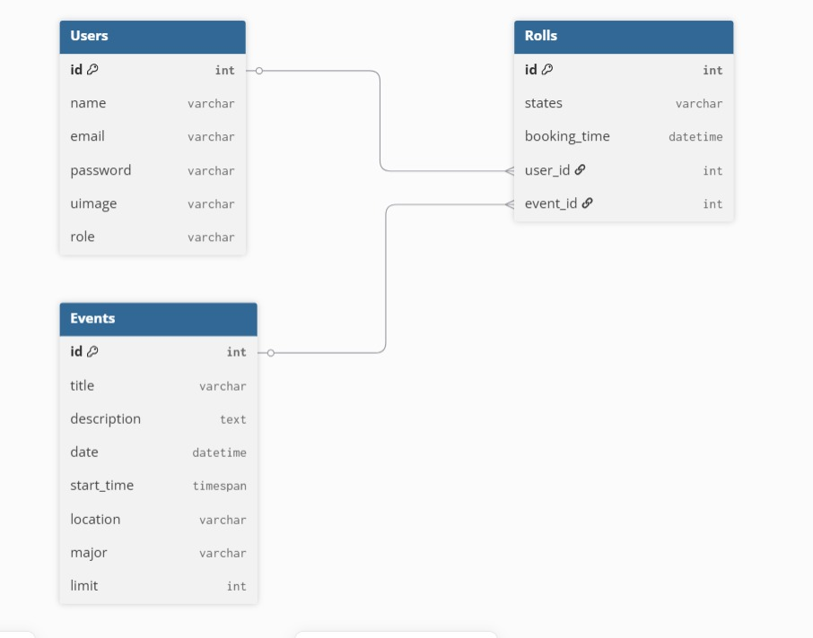
Figure 2 Database Schema

Chapter 3

Design
In this chapter, we will delve into the design aspects of the Graduation Project system. We will outline the high-level design goals and principles, propose a software architecture, design the user interface, and define the objects and their interactions within the system.

Define the high-level design goals and principles. Create a component diagram showing the major components of the system and their interactions.

Proposed Software Architecture

The project follows the Model-View-Controller (MVC) architectural pattern using ASP.NET Core 8.0:
- The Model Layer: Represents the data structure using Entity Framework Core. It maps C# classes (User, Event, Roll) directly to SQL database tables.
- The View Layer: Provides the user interface using Razor Views (.cshtml) combined with Bootstrap for responsive design. It displays data to the user and captures inputs.
- The Controller Layer: Handles user requests, processes business logic (like the waiting list algorithm), and returns the appropriate view.

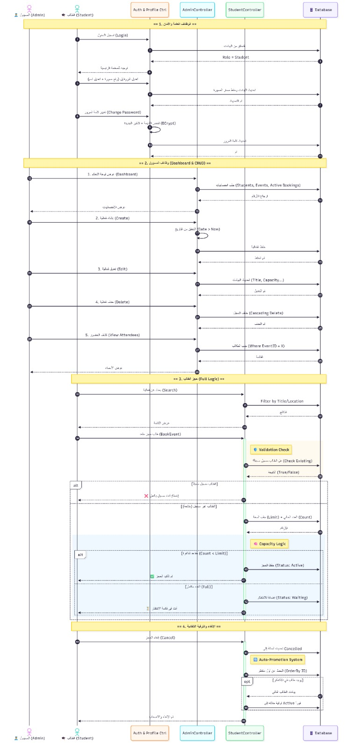
Figure 3 Sequence Diagram

Overview
This document explains the sequence diagram of the University Event Management System. The diagram illustrates the interaction flow between users, system controllers, and the database, covering authentication, event management, booking, waiting list handling, and automatic promotion

Participants (Lifelines)
Admin: Manages events and monitors registrations.
Student: Browses events, performs bookings, and manages registrations.
Auth & Profile Controller: Handles login, logout, and profile-related operations.
Admin Controller: Manages event-related administrative actions.
Student Controller: Handles student actions such as searching, booking, and cancellation.
Database: Stores and retrieves persistent system data.

1. Authentication and Profile Management
The sequence begins when an Admin or Student submits login credentials to the Auth & Profile Controller. The controller validates the credentials against the database. Upon successful authentication, a session is created and the user is redirected based on their role. Additional actions such as password changes and profile updates are handled within this component. Logout requests terminate the session securely.

2. Admin Dashboard and Event Management
After authentication, the Admin accesses the dashboard. The Admin Controller retrieves event statistics and booking data from the database. The Admin can create, edit, or delete events, with all changes validated and persisted in the database. The Admin may also view attendee lists for specific events.

3. Event Browsing and Booking (Student Flow)
Students interact with the system through the Student Controller. They can search for events using filters such as title or location. The controller retrieves matching events from the database and displays event details when selected.

4. Validation and Capacity Handling
Before completing a booking, the system validates that the event exists and that the student is not already registered. If capacity is available, the booking is saved with an Active status. If the event has reached its capacity, the booking is recorded with a Waiting status and the student is added to the waiting list.

5. Cancellation and Automatic Promotion
When a student cancels an active booking, the system updates the booking status and triggers the automatic promotion mechanism. The database is queried to locate the earliest waiting registration. If found, the student is automatically promoted from Waiting to Active, ensuring optimal seat utilization.

6. Logout
Users can log out at any time. The logout request invalidates the active session and securely returns the user to the login interface.

User Interface

The interface is designed to be simple and responsive.
- Navigation Bar: Provides easy access to "Home", "Events", "My Bookings", and "Profile".
- Dashboard (Admin): A dedicated area for administrators to manage content using a sidebar layout (AdminLTE template).
- Feedback Messages: The system uses TempData to display success or error messages (e.g., "Booking Confirmed", "Password Changed") to the user.

Object Design

- Class: User
  - Attributes: int Id, string Name, string Email, string Password,string uimage string Role.
  - Relationships: One-to-Many with Roll.
- Class: Event
  - Attributes: int Id, string Title,text description, DateTime Date,timespan start-time, string Location, string major,int Limit.
  - Relationships: One-to-Many with Roll.
- Class: Roll
  - Attributes: int Id, string States (active/waiting,cancel), DateTime BookingTime.
  - Role: Junction class linking User and Event.

Chapter 4

Test Plans
In this chapter, we will focus on the test plans for the Graduation Project system. Testing is a crucial phase in the software development lifecycle as it ensures that the system functions correctly and meets the specified requirements. We will outline the overall approach to testing, including the types of tests to be conducted, the necessary testing materials and resources, and the criteria for suspending and resuming testing activities. Furthermore, we will create individual test cases for each functional requirement or use case, specifying input data, expected outcomes, and pass/fail criteria. Finally, we will organize the test cases into a test suite for efficient execution and management.

Approach

Describe the overall approach to testing, including the types of tests to be conducted.
Specify testing materials and resources required.
Define criteria for suspending and resuming testing activities.

Test Cases

Create individual test cases for each functional requirement or use case.
Specify input data, expected outcomes, and pass/fail criteria for each test case.
Organize test cases into a test suite for efficient execution and management.
This comprehensive outline should guide you through the process of creating a detailed project plan for your Bachelor's software engineering project, ensuring that all relevant aspects are covered effectively.

References
Using IEEE style such as
  - Alhroob, W. Alzyadat, I. Almukahel, and H. Altarawneh, "Missing data prediction using correlation genetic algorithm and SVM approach," International Journal of Advanced Computer Science and Applications, vol. 11, no. 2, 2020.
  - Bootstrap 4.2v + 5.3v templets
  - Use Case drow by https://www.visual-paradigm.com/
  - Admin LTE Templates v3.2+v4

1.Home Page
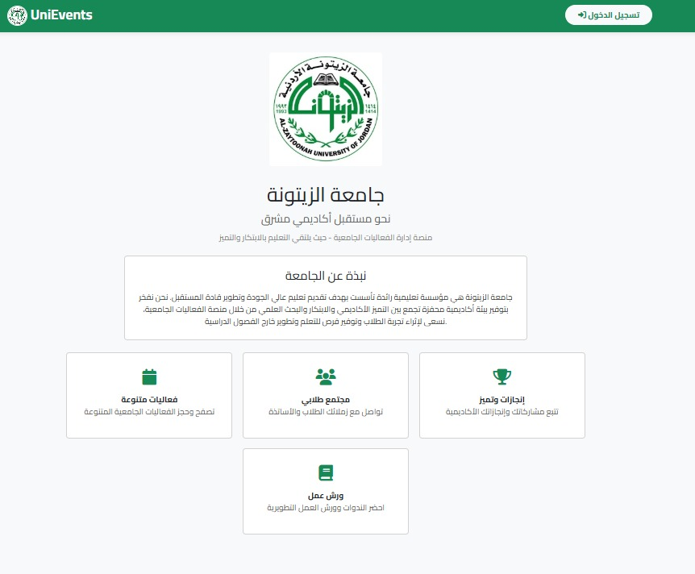

2.Login Page
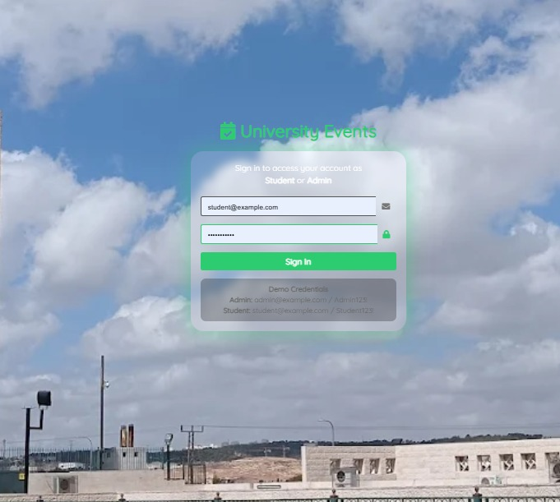

- User Home Page
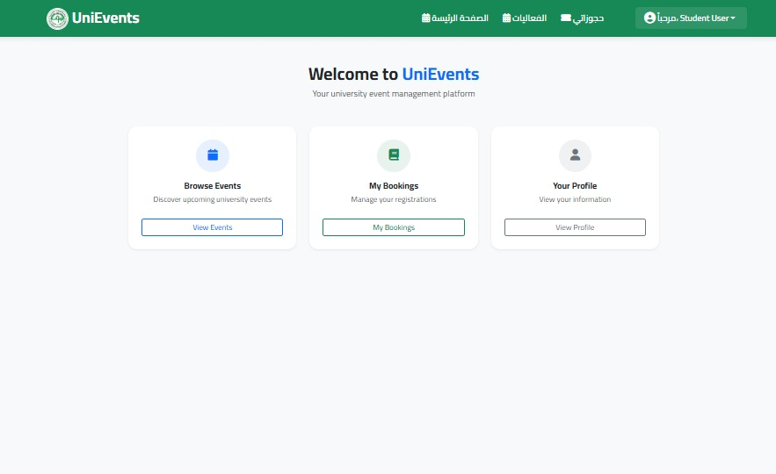

- Admin Home Page
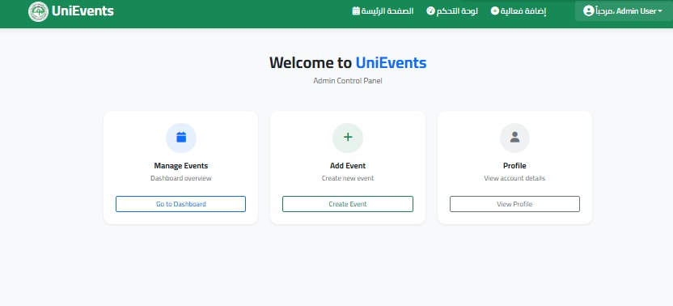

- Profile Page
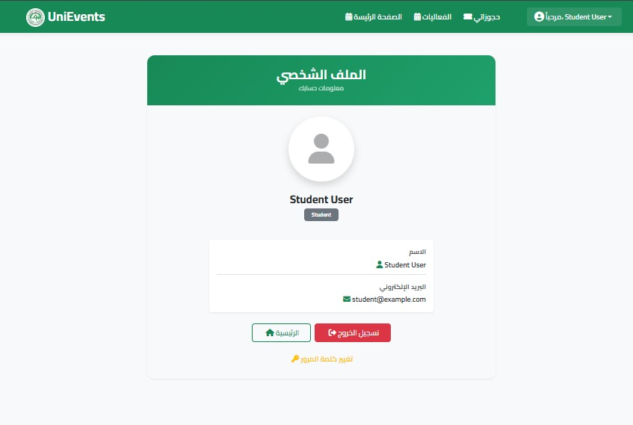

6.Admin Dashboard Page
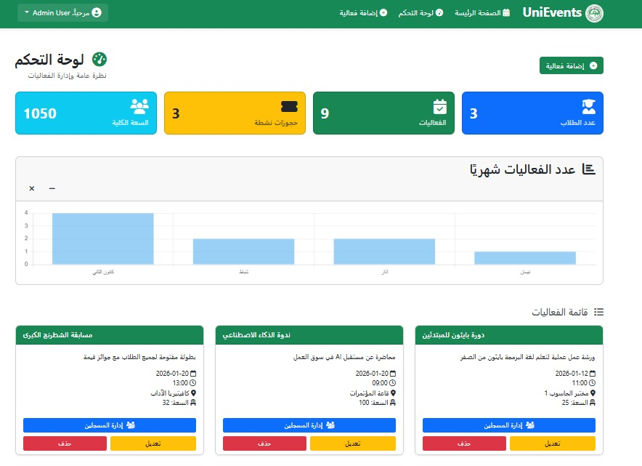

7. Admin Create & Update Page
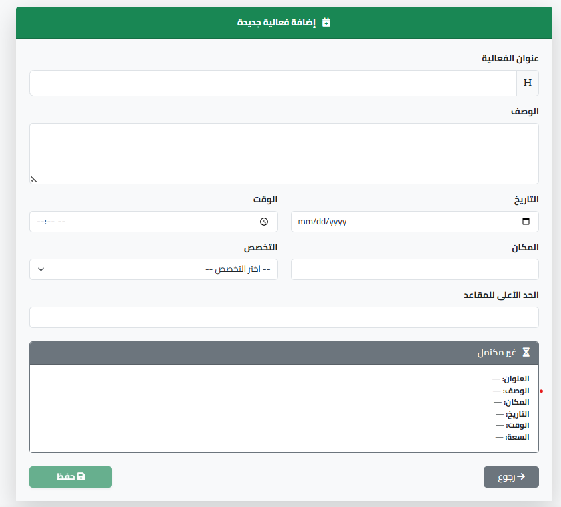

8.Admin Delete Event
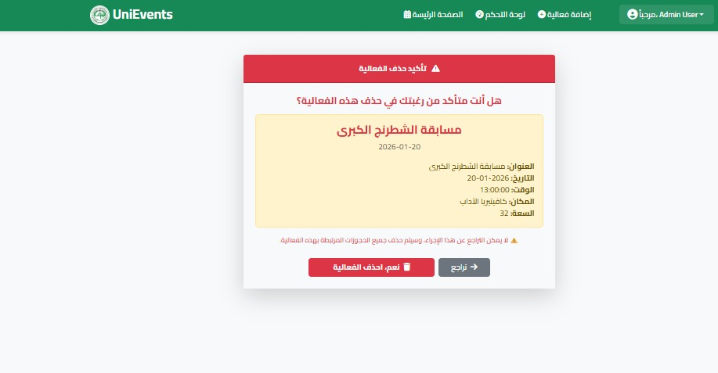

9. Admin View Students Page
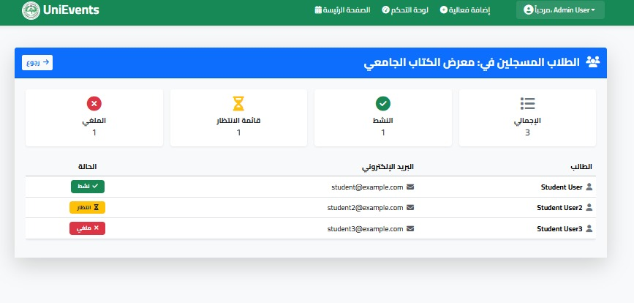

10.Student My Event Page
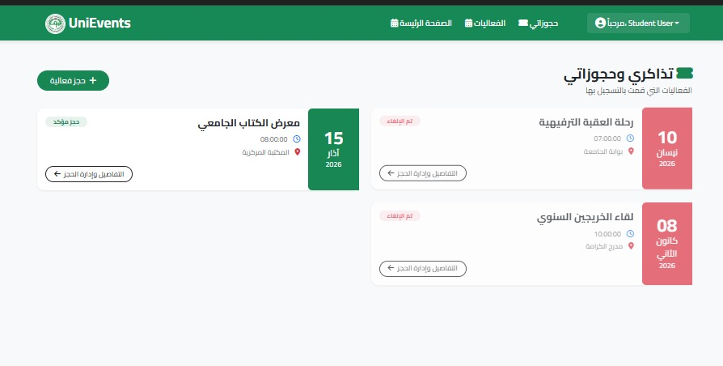

11.Student View Events Page
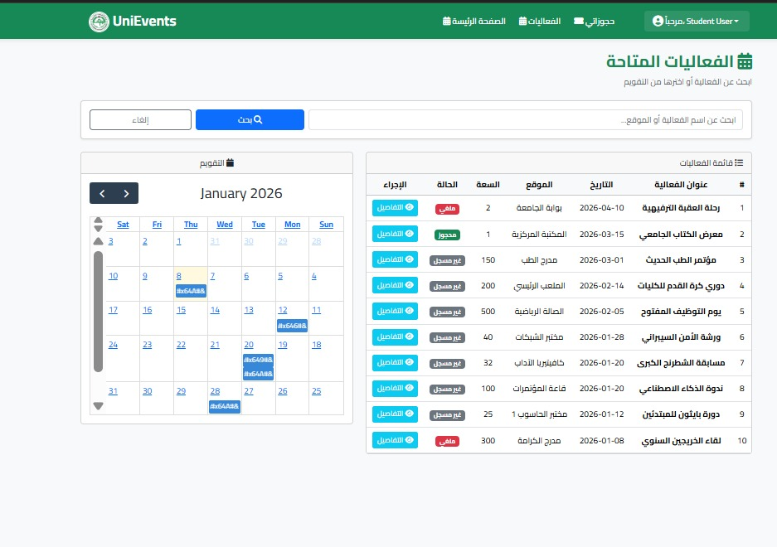

12.Student My Bookings & Details Event Page
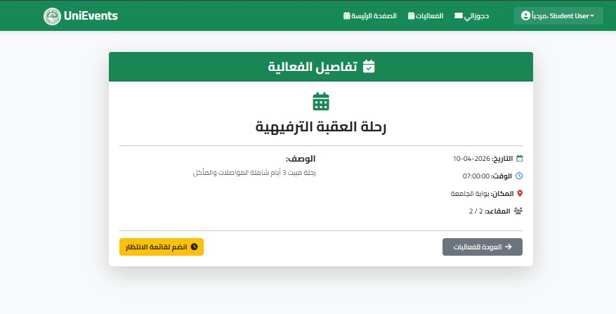

Appendix Snipping Code
- AdminController
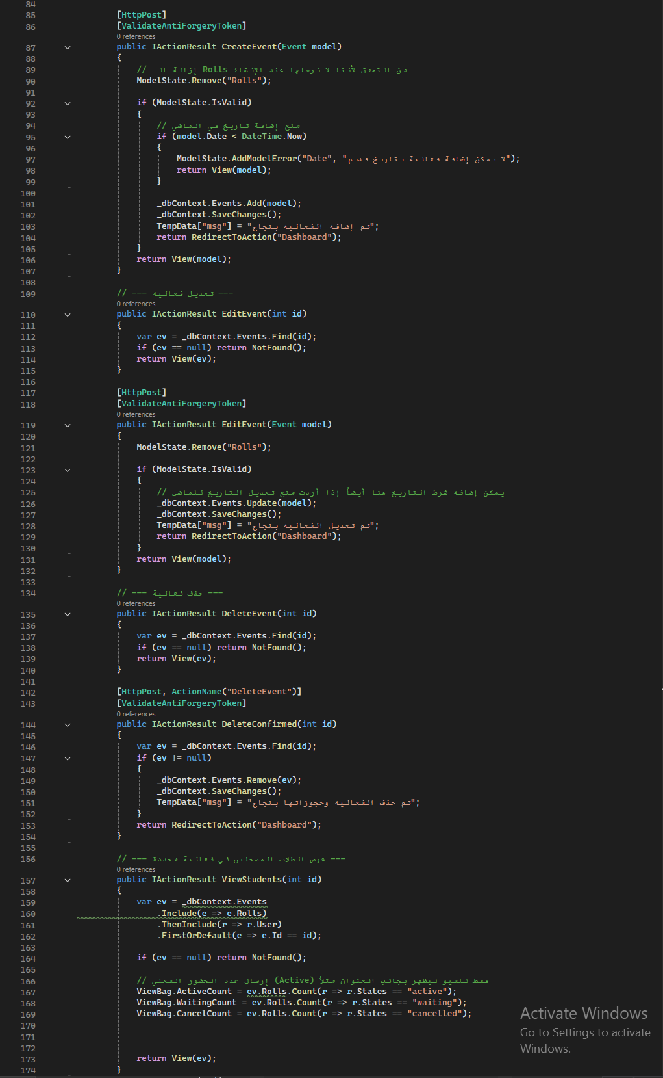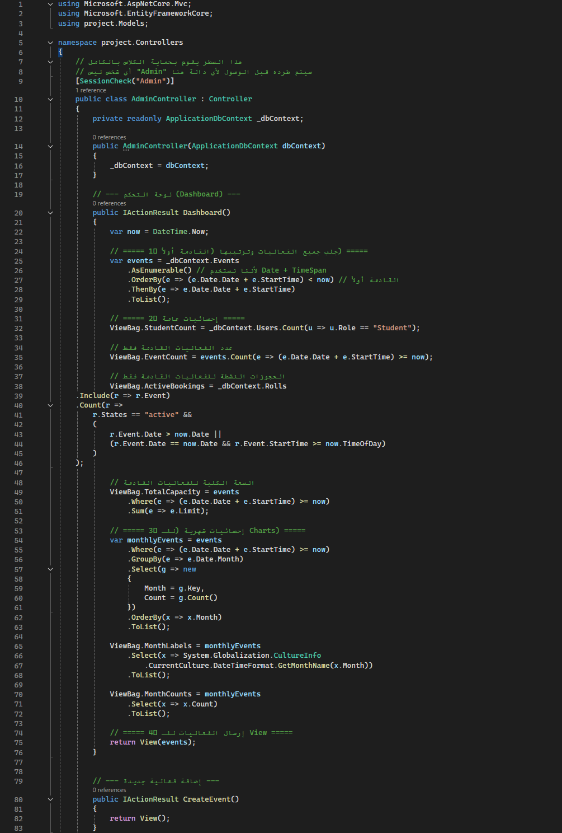

- HomeController

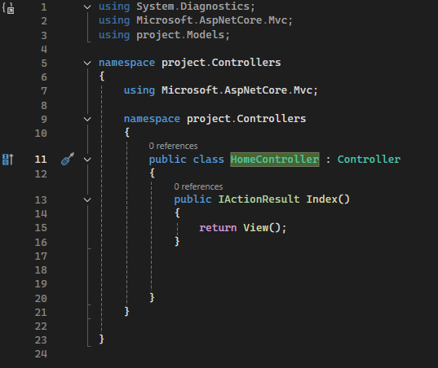

- UserController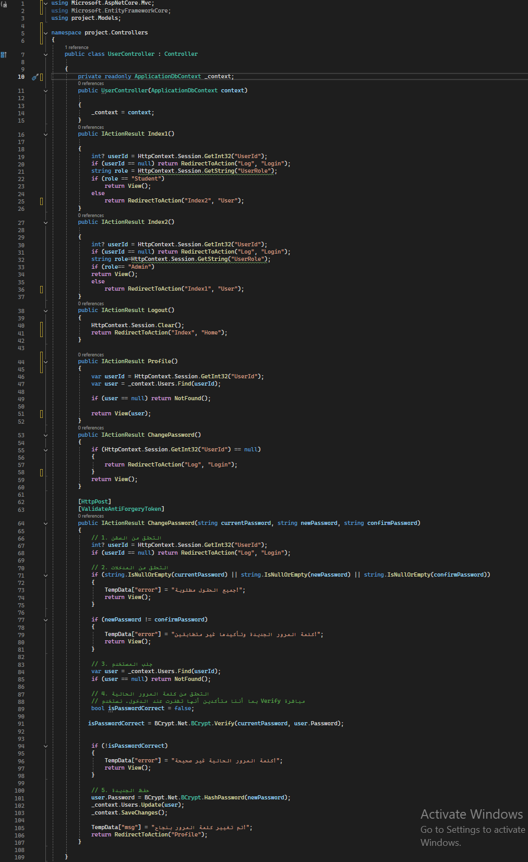

- StudentController

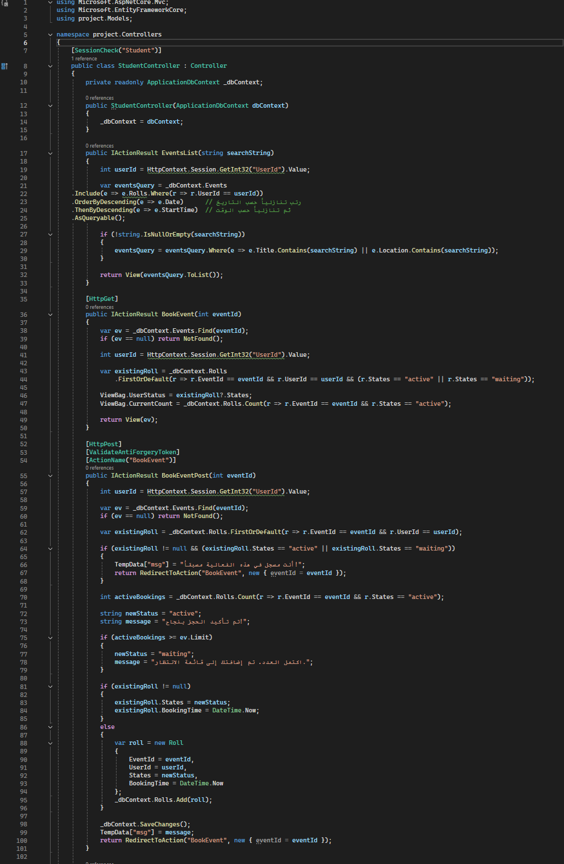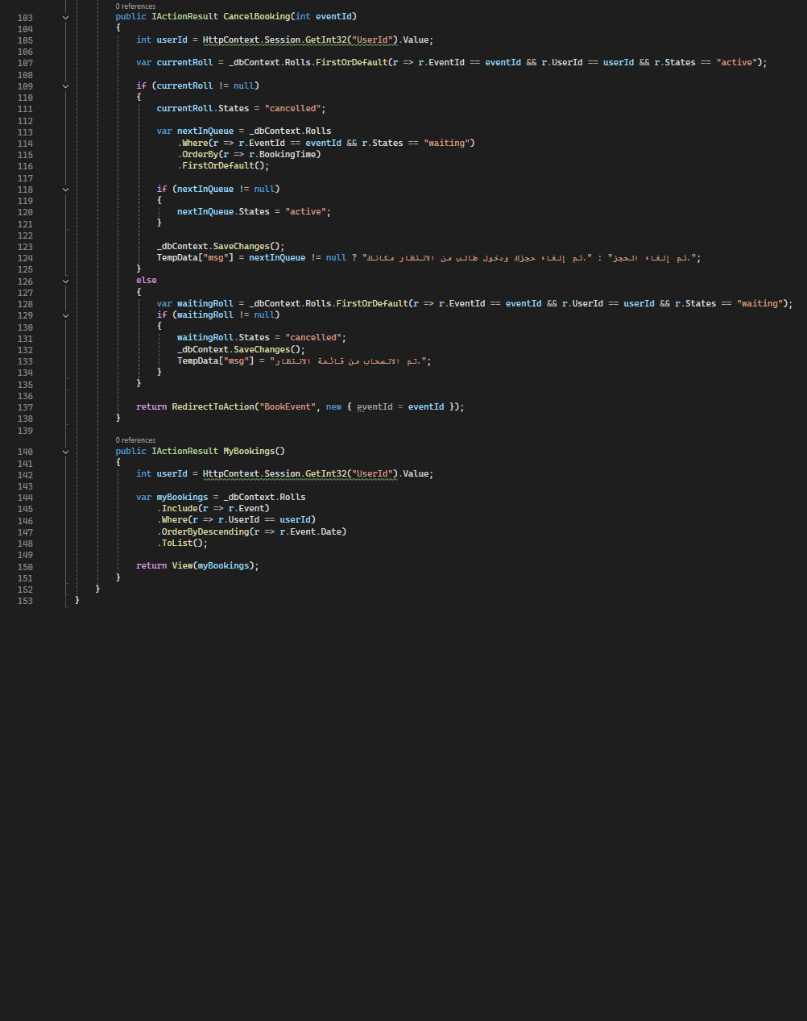
- LoginController
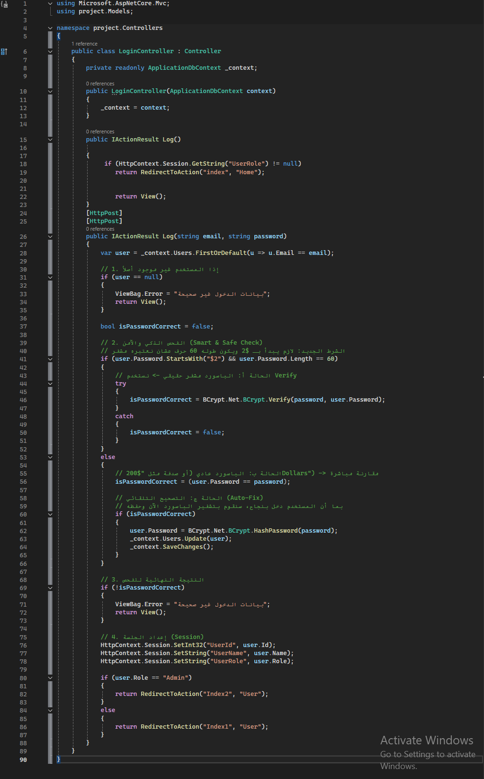

- project.Models

- ApplicationDbContext
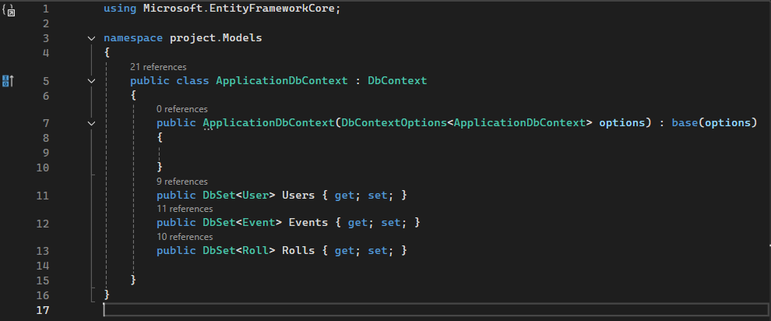

- ErrorViewModel
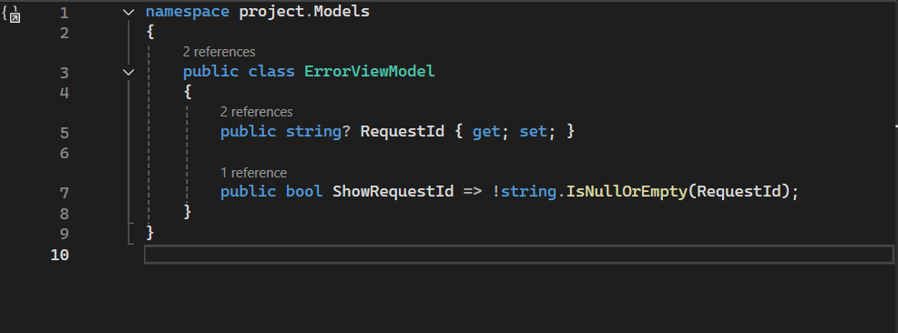

- Event
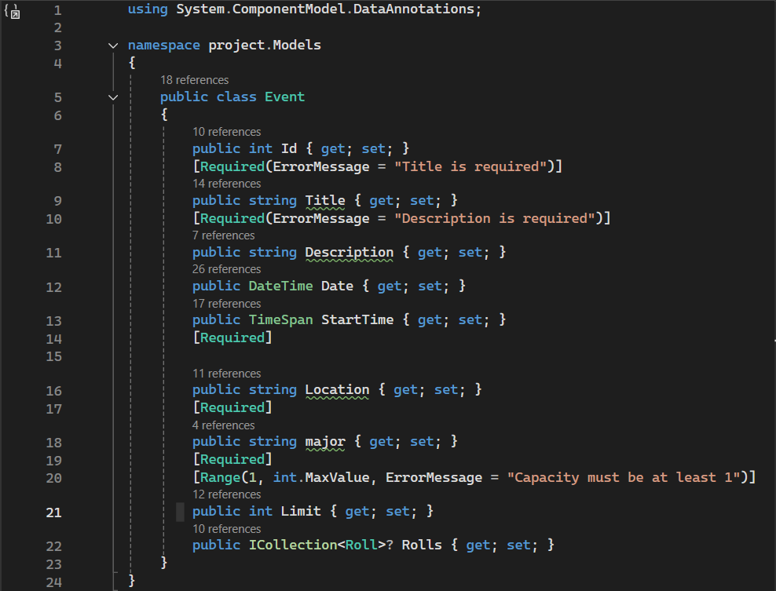

- Roll
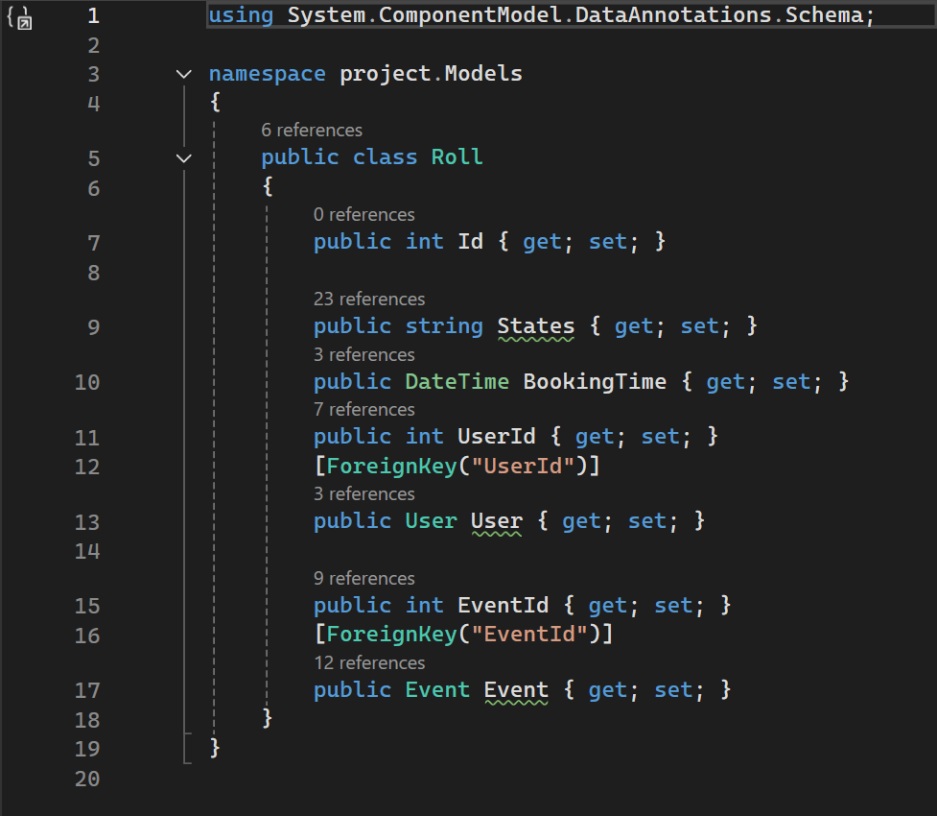

- User
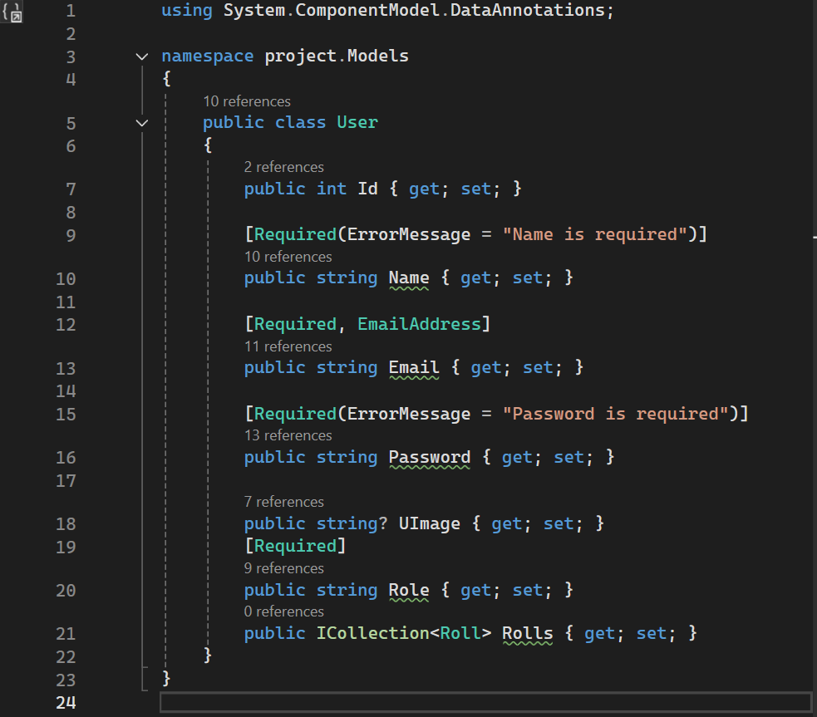

- Views
- Shared
- _Layout.cshtml

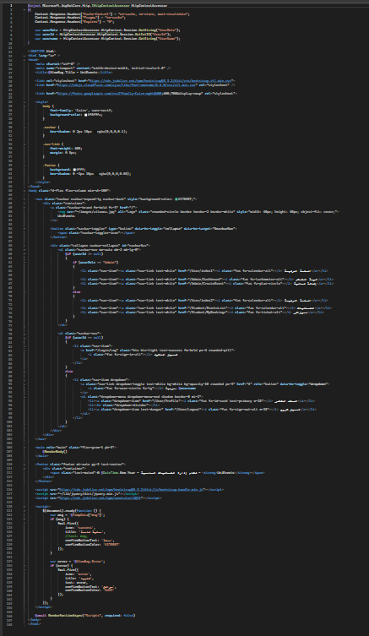

- SessionCheckAttribute.cs
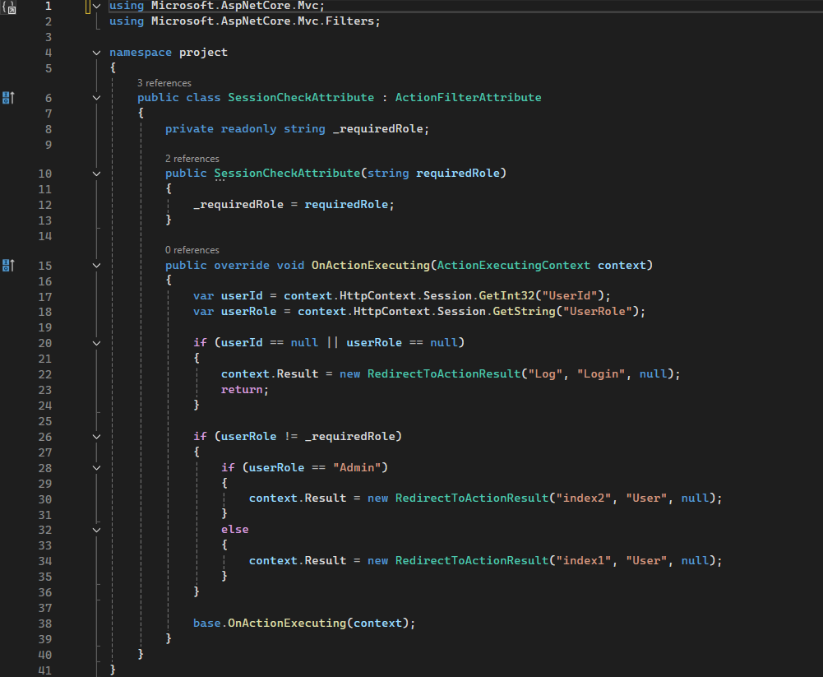

- AdminController.
- DashboardIndex.cshtml
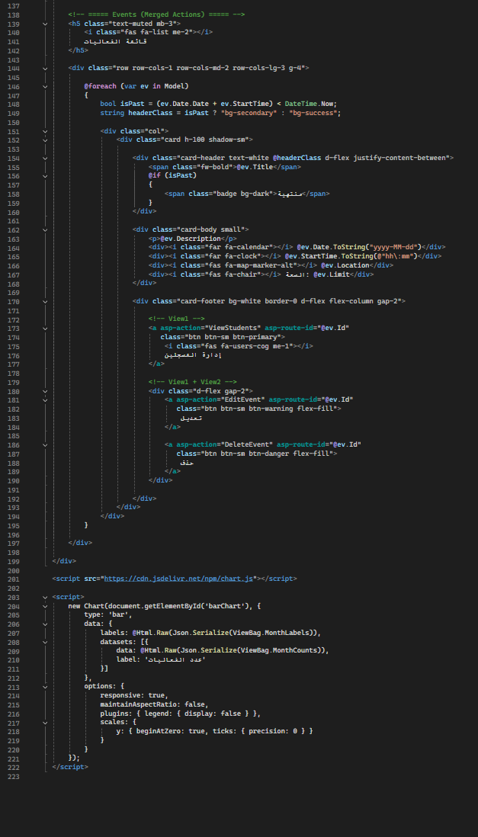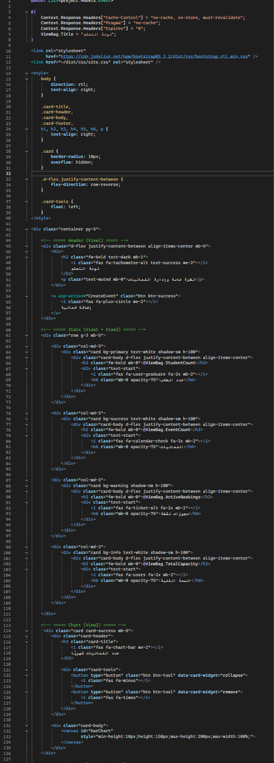

- ViewStudents.cshtml

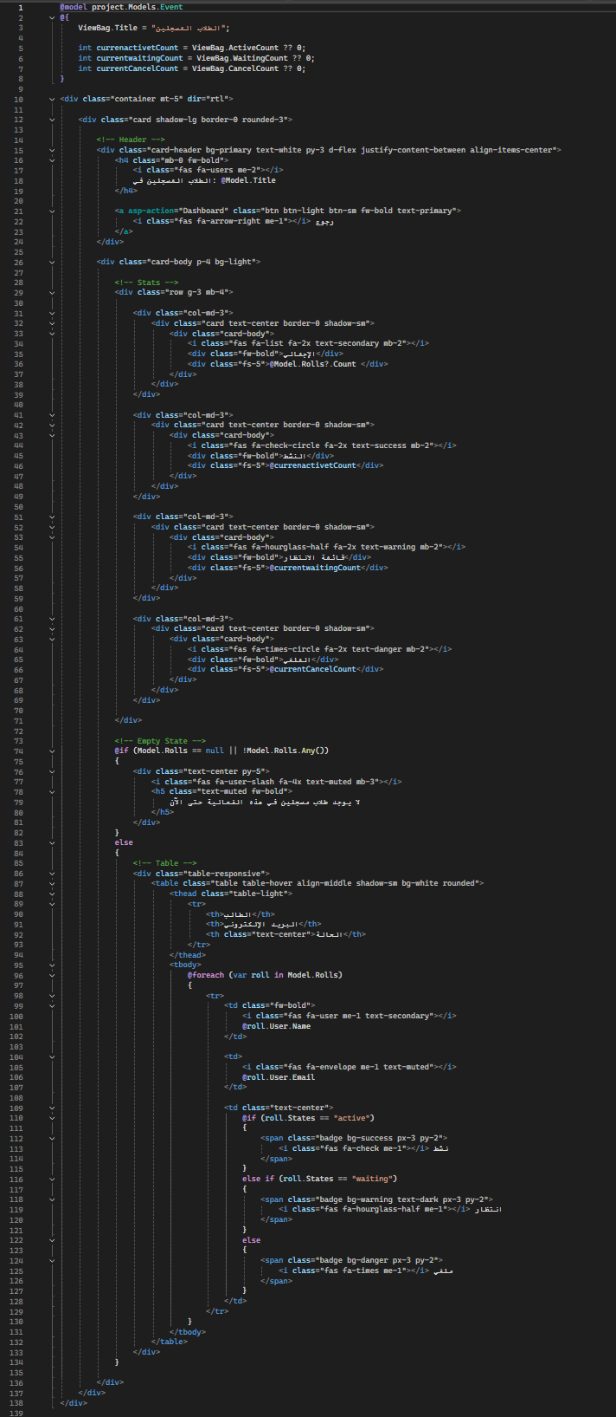

- CreateEvent.cshtml

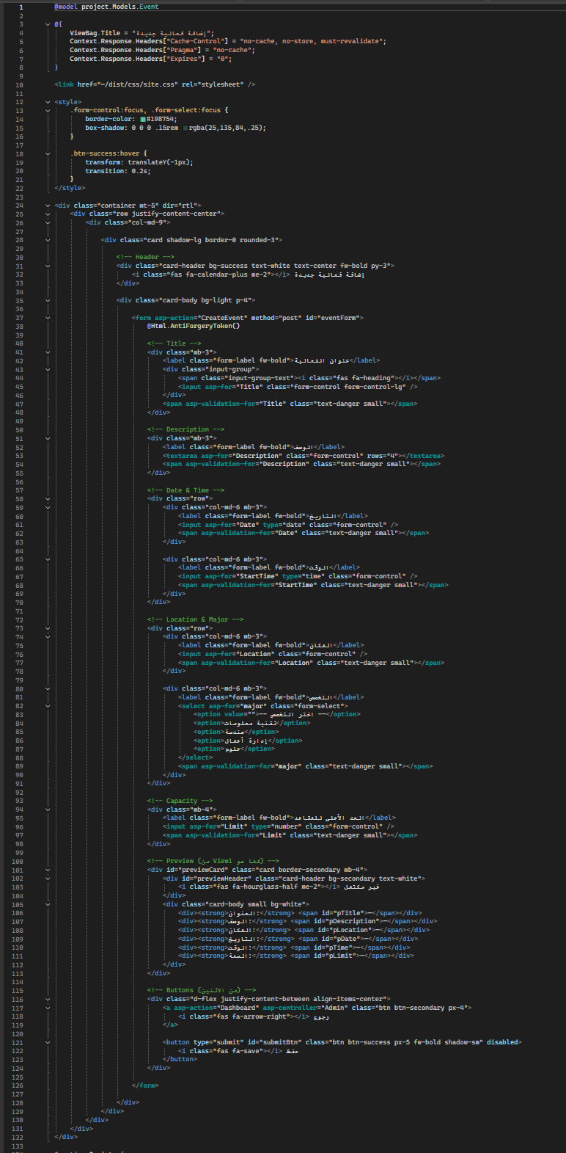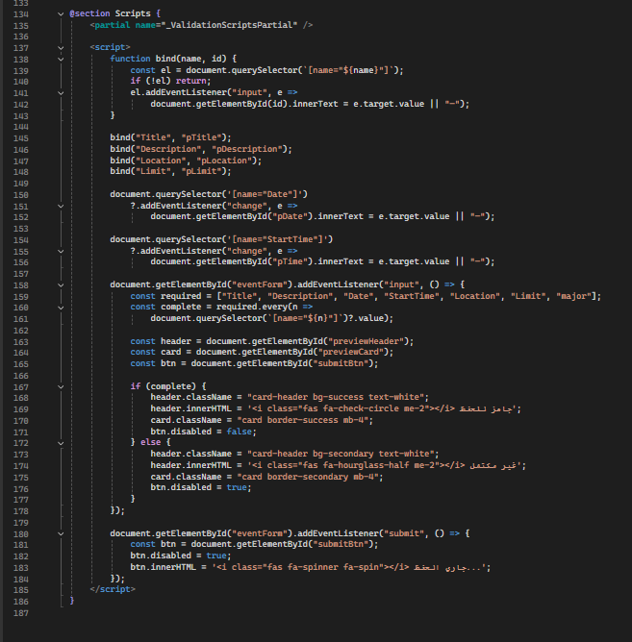

- EditEvent.cshtml

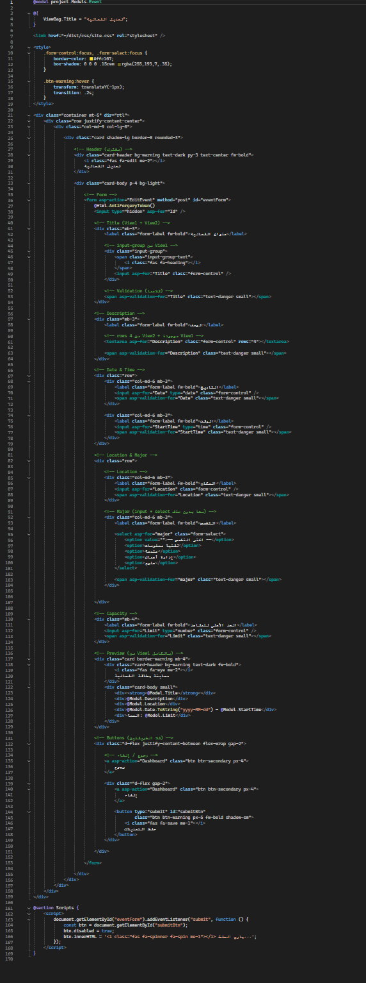

- DeleteEvent.cshtml

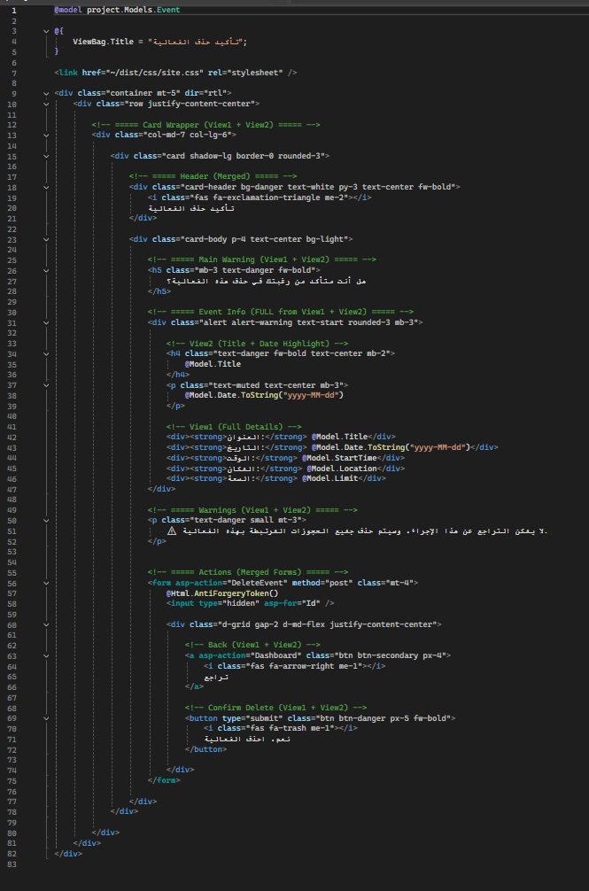

- Home.
- Index.cshtml

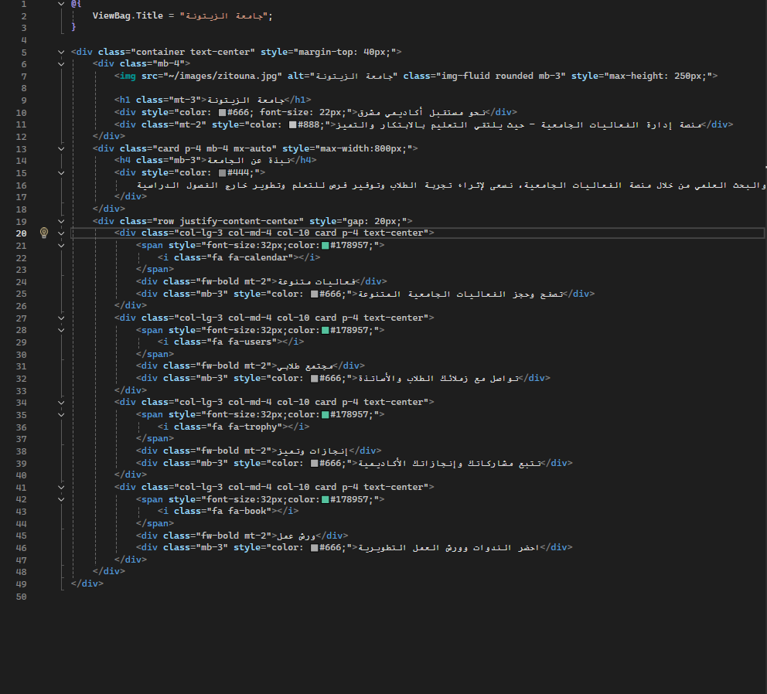

- User.
- Profile
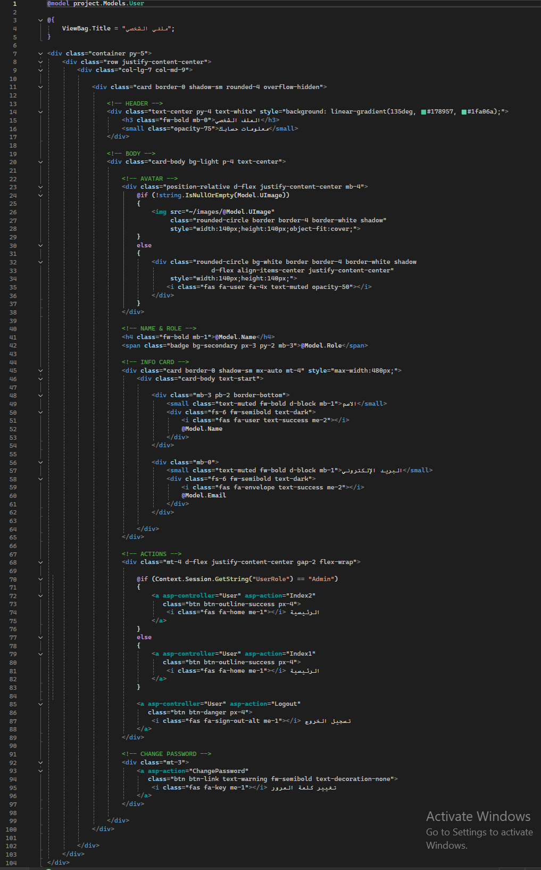
- Index1

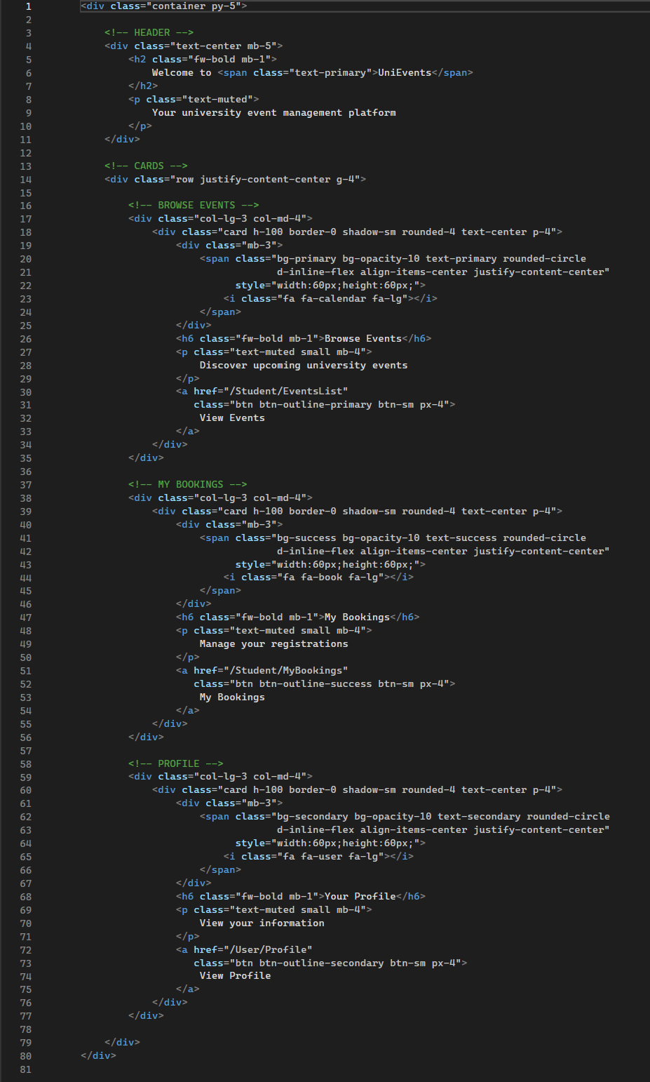

- Index2

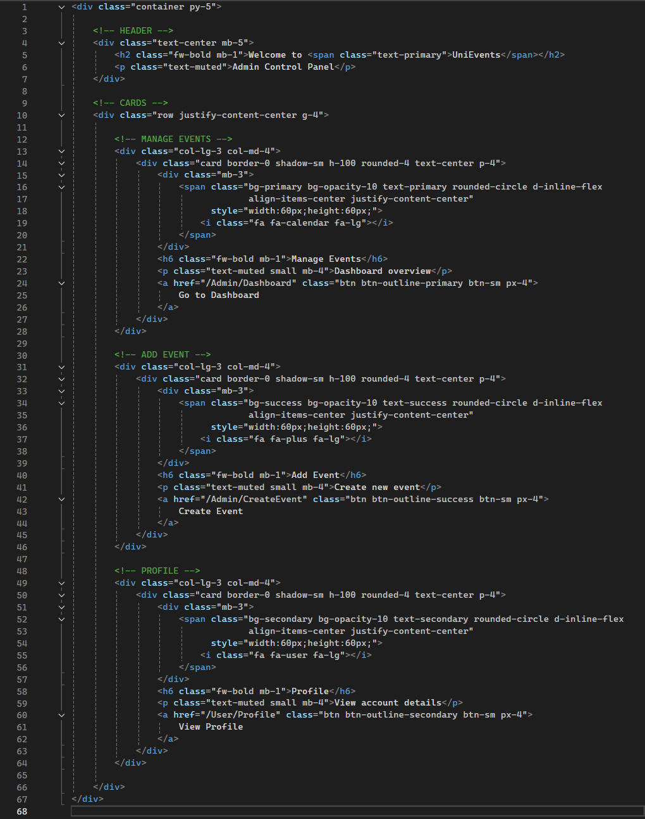

- ChangePassword
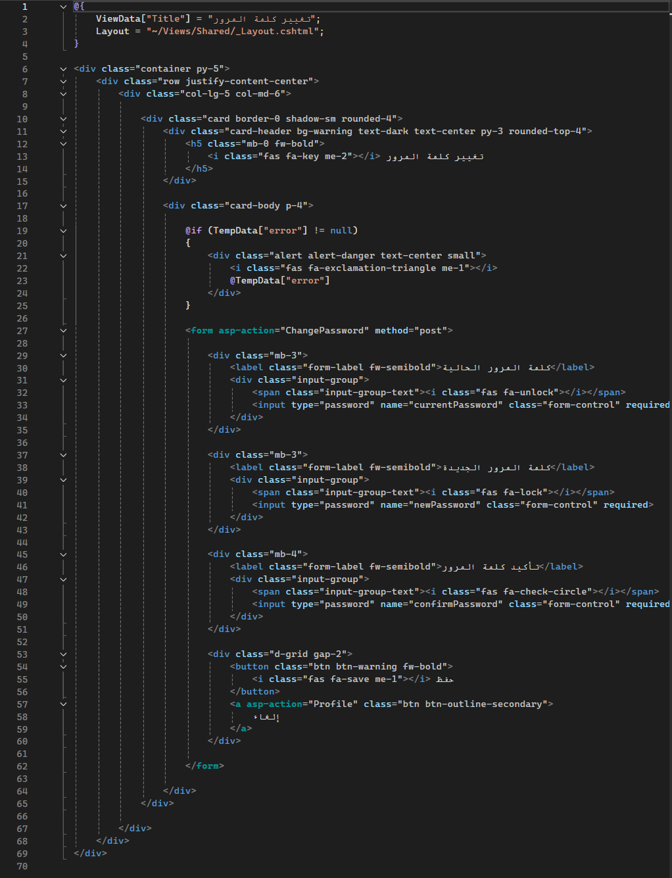
- Student.
- EventsList

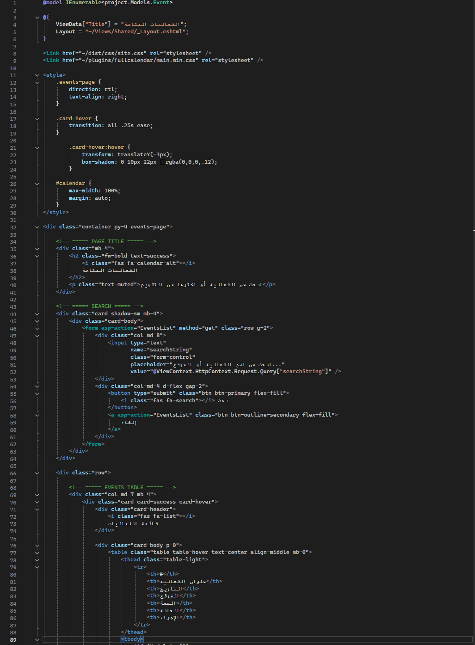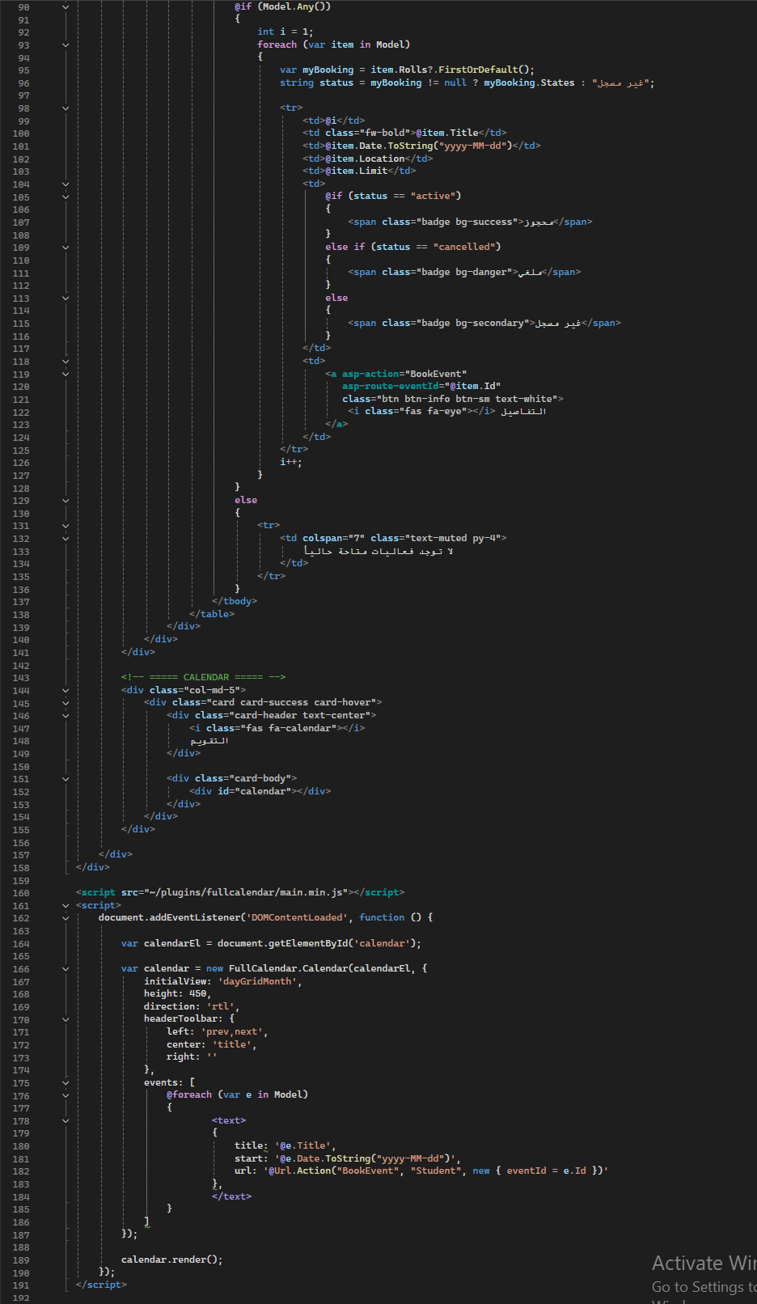

- BookEvent

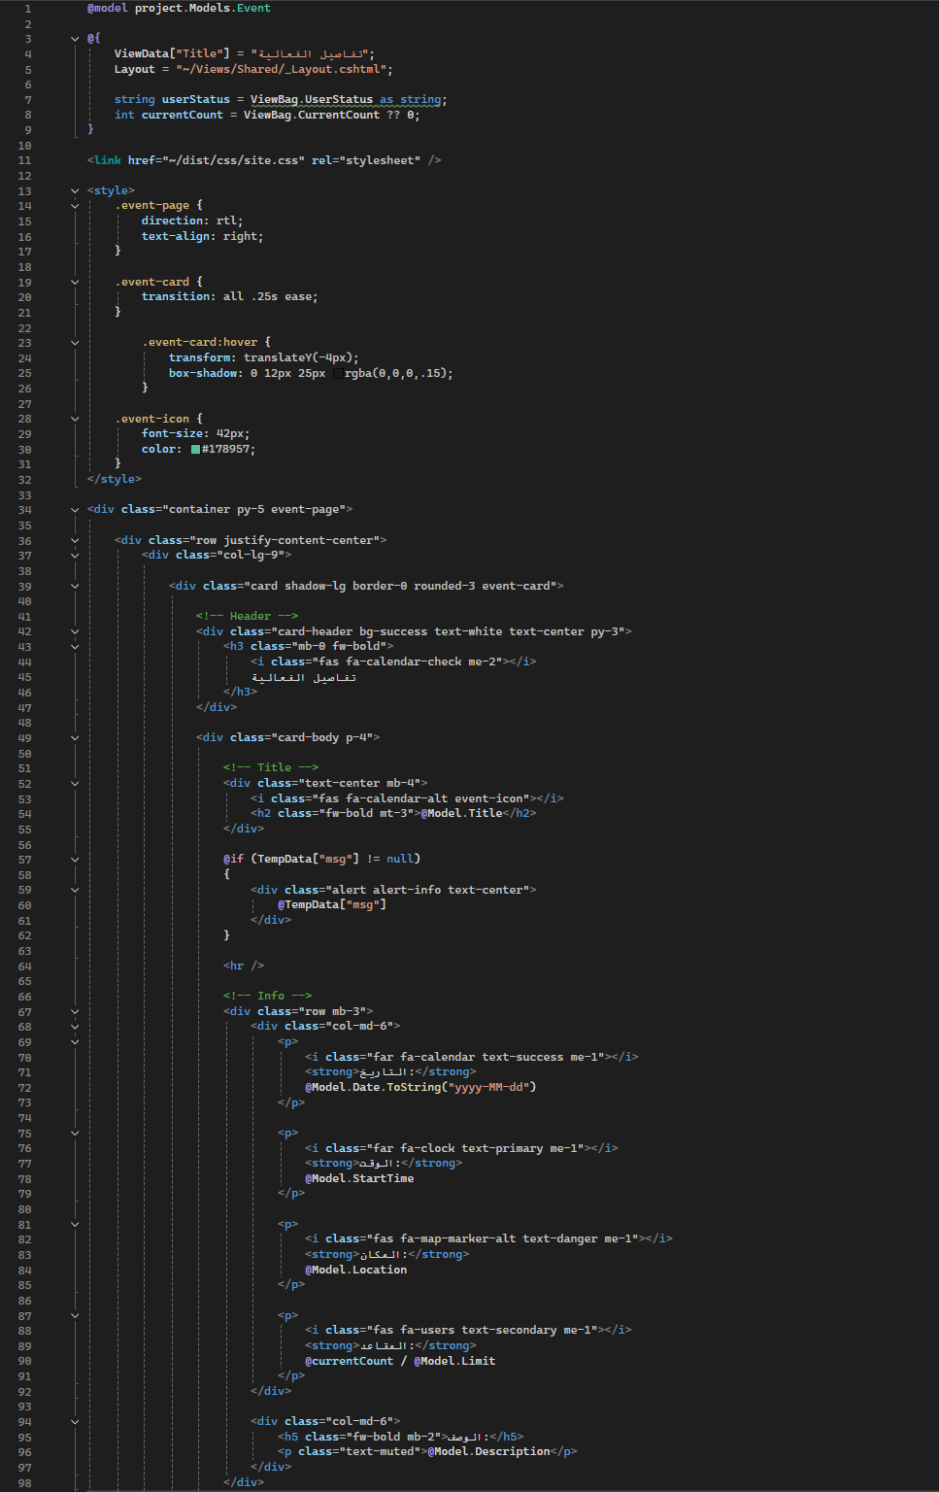
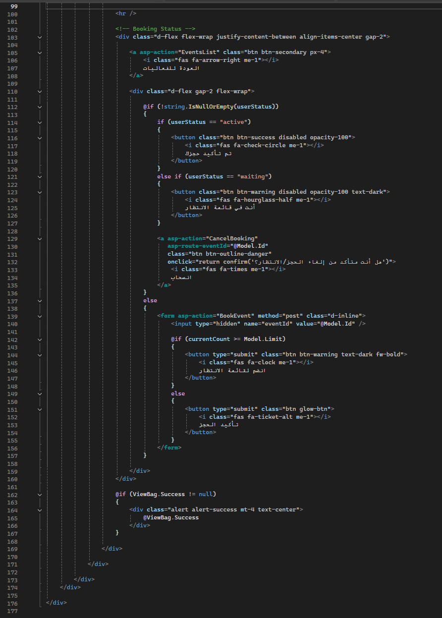

- MyBookings

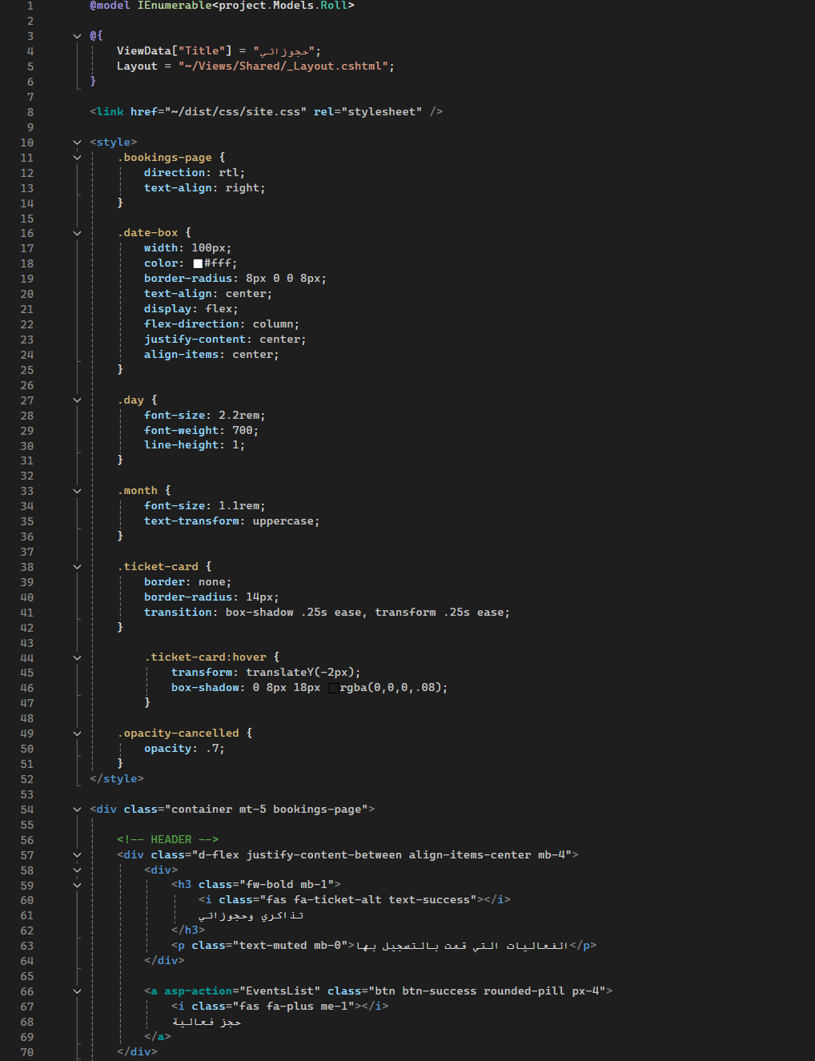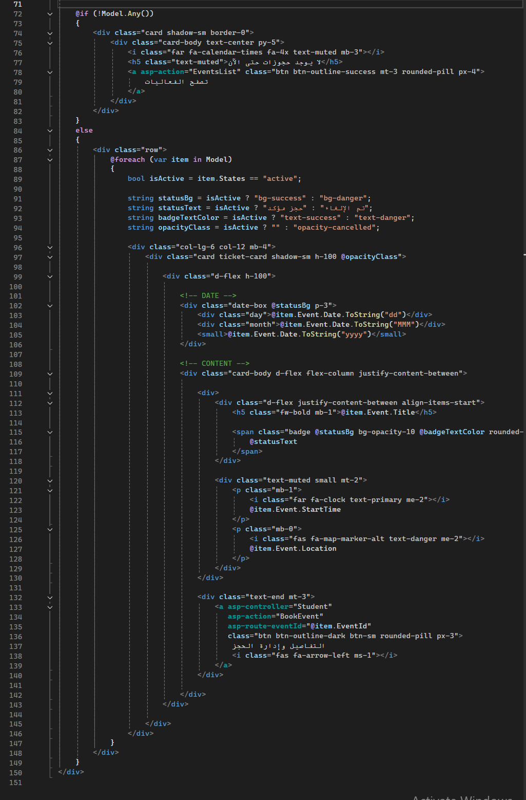

- Login.
- log.cshtml

